Lost and Found Process

- Receive lost item and log it in CA
- Make sure you input the person who turned in the item

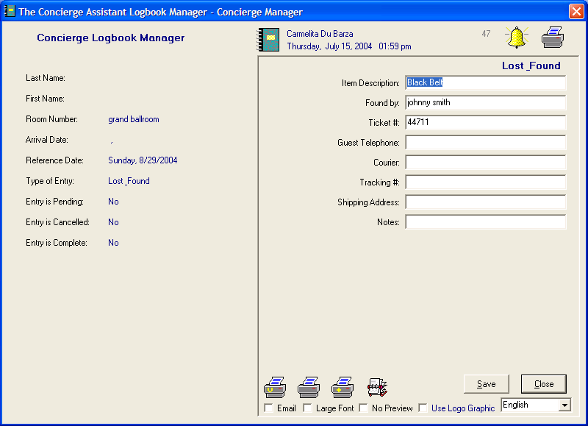

- Reference date will be the date the item is given away (90 days ahead)

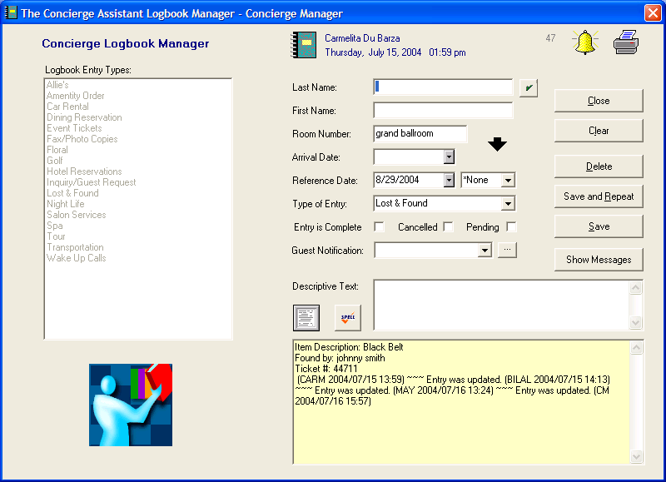

- If the item was not found in a room, type the location where it was found in the room number field
- When the guest calls, fill out the information required and mark item as pending (blue)

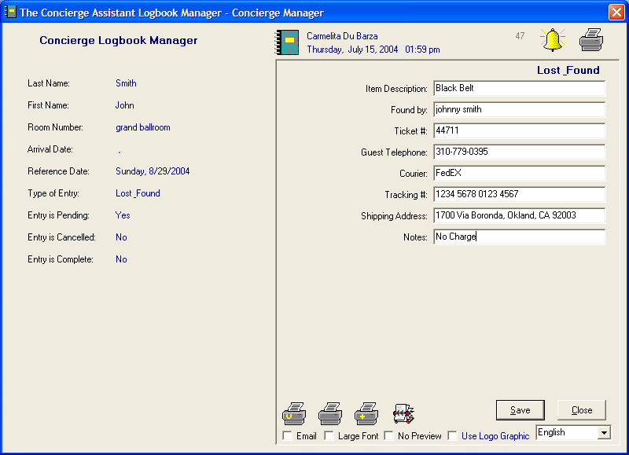

- When the item is shipped and guest has received it, mark item as completed (black)

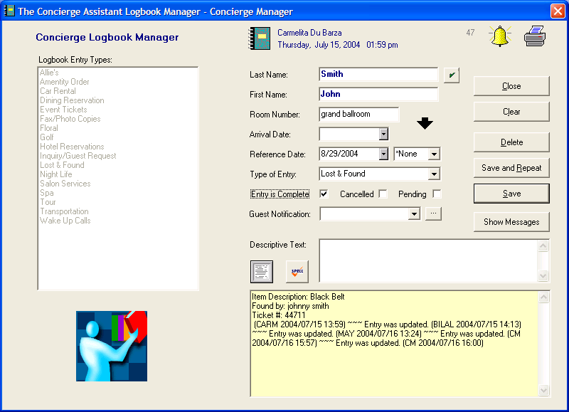

- Everyday, hit “due and overdue” on the logbook screen. If there are some items in red for lost and found,

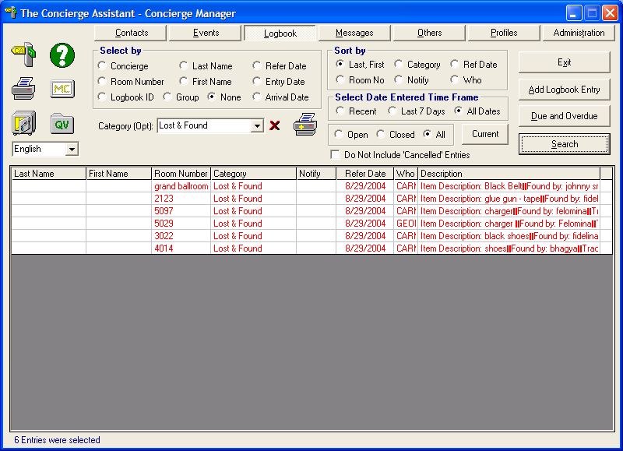

- Print the Lost and Found report from the “Logbook Report Writer” in the “Others” Screen

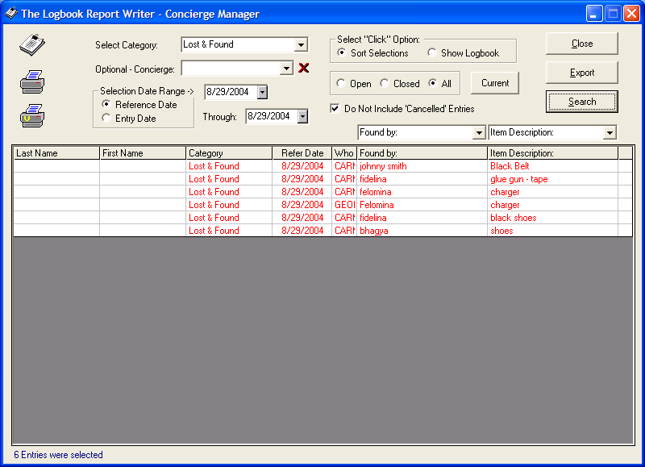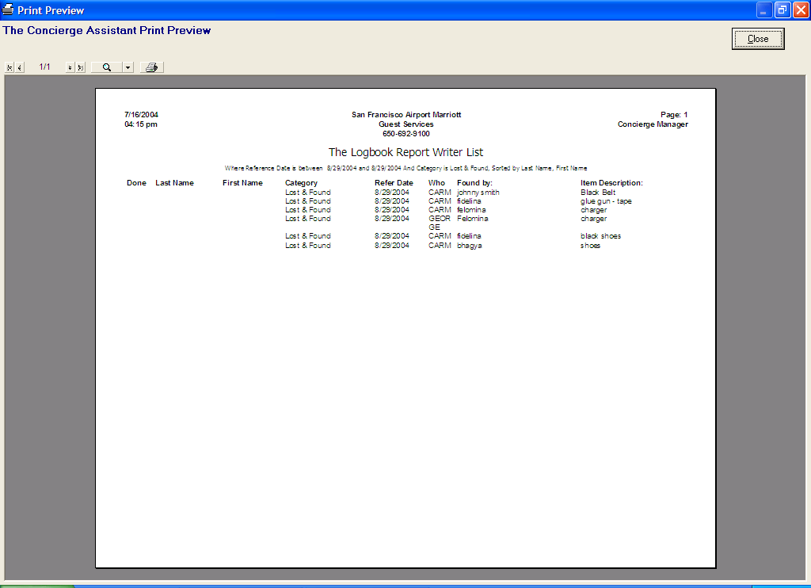

- Proceed to give Items away.

